NVEditor User Guide

Version: 1.0.16
DocCode: SW -BASE-UG -0004
Date: 2016-01-28


www.spreadtrum.com
Important Notice
Copyright Notice
Copyright © 2010, Spreadtrum Communications, Inc. All rights reserved.
Trademarks
Spreadtrum Communications, Inc. and Spreadtrum Communications, Inc.'s products are exclusively owned by Spreadtrum Communications, Inc. References to other companies and their products use trademarks owned by the respective companies and are for reference purpose only.
Warranty Disclaimer
Spreadtrum Communications, Inc. makes no representations or warranties, either expressed or implied, by or with respect to anything in this document, and shall not be liable for any implied warranties of merchantability or fitness for a particular purpose or for any indirect, special or consequential damages.
Confidentiality
The information contained herein (including any attachments) is confidential. The recipient hereby acknowledges the confidentiality of this document, and except for specific purposes, this document shall not be disclosed to any third party.
About This Document

Purpose
The NVEditor User Guide describes the functions and how to use Spreadtrum NVEditor.

Intended Audience
This document is intended for:
- NVEditor development engineer

Organization
This document consists of three chapters and is organized as follows.
Chapter | Describes
1 Introduction | File composition and running requirements of NVEditor.
2 Quick Start Guide | The functions, running requirements, and brief procedure for using NVEditor.
3 Interface Description | The elements on the main interface.
4 Files | The files and values that can be modified.

Contents
1 Introduction 1-1
1.1 System Overview 1-1
1.2 File Composition 1-1
1.3 Running Requirements 1-2
2 Quick Start Guide 2-3
2.1 Brief Procedure 2-3
2.1.1 Running the Program 2-3
2.1.2 Opening a NVEditor Project File 2-3
2.1.3 Loading Parameters 2-3
2.1.4 Editing Parameters 2-3
2.1.5 Editing Parameters ItemID 2-4
2.1.6 Saving Parameters 2-4
2.1.7 Saving the Project File 2-4
3 Interface Description 3-5
3.1 Main Interface 3-5
3.2 Parameter Editing Window 3-5
3.2.1 List Box 3-5
3.2.2 Editing the Item Value 3-7
3.2.3 Inserting an Item 3-7
3.3 Menus 3-10
3.3.1 File 3-10
3.3.2 Facility 3-16
3.4 Taskbar 3-19
3.5 Command line 3-19
4 Files 4-21
4.1 Project File 4-21
4.2 Module File 4-21
4.3 Image File 4-21
4.4 Values that Can Be Modified 4-21
4.5 Points for Attention 4-21

Figures
Figure 2-1 Editing a parameter 2-3
Figure 3-1 NVEditor main interface 3-5
Figure 3-2 Parameter editing list box 3-6
Figure 3-3 Editing the item value 3-7
Figure 3-4 Item inserting menu 3-7
Figure 3-5 Input new item information dialog box 3-8
Figure 3-6 Paste Settings dialog box 3-9
Figure 3-7 File menu 3-10
Figure 3-8 New submenu items 3-11
Figure 3-9 New Module dialog box 3-12
Figure 3-10 Port Settings dialog box 3-13
Figure 3-11 Save Imag Diag Box 3-15
Figure 3-12 Facility menu 3-16
Figure 3-13 Erase Flash dialog box 3-17
Figure 3-14 Modify Functions dialog box 3-18
Figure 3-15 Find Dialog 3-18
Figure 3-16 Taskbar icons 3-19

Tables
Table 1-1 File composition 1-1
Table 3-1 Item inserting menu items 3-8
Table 3-2 Input new item information dialog box elements 3-8
Table 3-3 File menu items 3-10
Table 3-4 New submenu items 3-11
Table 3-5 New Module dialog box elements 3-12
Table 3-6 Port Setting dialog box elements 3-13
Table 3-7 save Image dialog box elements 3-14
Table 3-8 Facility menu items (part) 3-15
Table 3-9 Taskbar icons 3-17

Introduction

System Overview
NVEditor is used to edit and save the NV parameters in modules. It performs the following functions:
- Loading the NV parameters from the module through a serial port
- Providing interfaces for editing the parameters
- Writing the modified parameters in the module.

File Composition
NVEditor consists of the files described in Table 1-1.
                - File composition
Type | File
*.exe | NVEditor.exe
*.dll | BMPlatform.dll
*.dll | Channel.dll
*.dll | ChanMan.dll
*.dll | CommSock.dll
*.dll | CommUart.dll
Configuration file | BMError.ini
Configuration file | BMFileType.ini
Configuration file | BMTimeout.ini
Configuration file | Channel.ini
Configuration file | Functions.ini
Configuration file | NVEditor.ini

Running Requirements
NVEditor runs on Windows 2000. At least one usable serial port is required.

Quick Start Guide

Brief Procedure

Running the Program
Run NVEditor.exe.

Opening a NVEditor Project File
You can use the following methods:
- Choose File > OpenProject.
- Click the taskbar icon OpenProject.
- Select the newly opened project file listed on the File menu.

Loading Parameters
          - Connect the module to the serial port.
          - Choose File > LoadFromPhone.
A dialog box is displayed.
          - Set the parameters in the dialog box and click OK.

Editing Parameters
Double-click the parameter to be edited or click the parameter and press Enter. An edit box is displayed, as shown in Figure 2-1.
              - Editing a parameter

Editing Parameters ItemID
Double-click the ItemID parameter to be edited or chose the nvitem line then right click. An Menu showed, select “modify ItemID”. A Diaglog box is displayed, as showed in Figure 1-2.
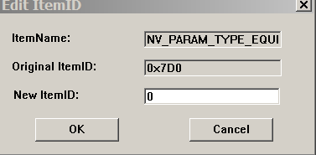

Saving Parameters
          - Connect the module to the serial port.
          - Choose File > SaveToPhone.
A dialog box is displayed.
          - Set the parameters in the dialog box and click OK.

Saving the Project File
Save the project file and quit the program.

Interface Description

Main Interface
              - NVEditor main interface
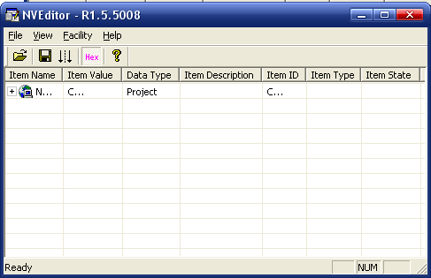

Parameter Editing Window

List Box
Figure 3-1 shows the parameter editing list box.
              - Parameter editing list box
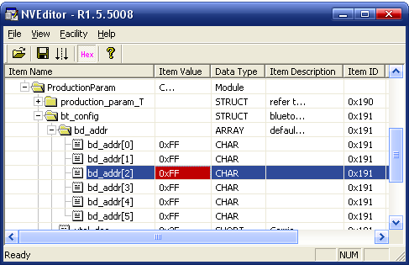

Item Name
This column lists the item names.

Item Value
This column lists the item values.
Some parameters, if configured incorrectly, may lead to hardware damage. These parameters are not allowed to be edited.

Data Type
The data types include the following:
- Project: project file at the top of the column. There is only one project file.
- Module: module
- Struct: structure
- Array: array
- Char: character
- Short: 16 bit integer
- Long: 32 bit integer
- ASTRING: ANSI string
- WSTRING: Unicode string

Item Description
This column lists the meanings of the items.

Item ID
This column lists the item IDs.
All the items are saved by blocks in Flash. Each ID maps a block and items of the same ID are saved in the same block.

Item Type
This column lists the item type, namely, item.

Item State
This column lists the item state, namely, inactive.

Editing the Item Value
Double-click the value to be edited or click it and press Enter. See Figure 3-1.
              - Editing the item value
- For project or module parameters, the full directory is listed.
- For other parameters, the values are listed. The default value is in decimal. To type hex values, add 0x.

Inserting an Item

Item Inserting Menu
Figure 3-1 shows the item inserting menu.
              - Item inserting menu
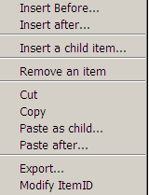

Table 3-1 describes the item inserting menu items.
                - Item inserting menu items
Menu Item | Description
Insert before… | Insert an item before the current item.
Insert after… | Insert an item after the current item.
Insert a child item… | Insert a child item of the current item.  Only struct or array has child items.
Remove an item | Remove the current item.
Cut | Cut the current item.
Copy | Copy the current item.
Paste as child | Paste the copied item as the first child item of the current item.
Paste after | Paste the copied item after the current item.
Modify ItemID | Modify NV ItemID, only support parents’ update

Input New Item Information Dialog Box
              - Input new item information dialog box
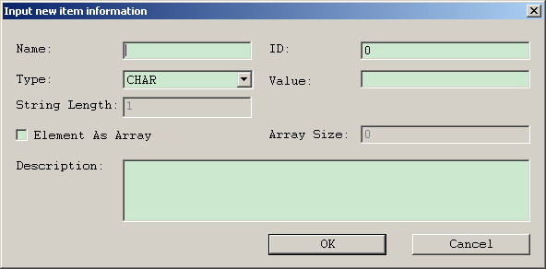

                - Input new item information dialog box elements
Element | Description
Name text box | Item name
ID text box | Item ID
Type drop-down list box | Data type
Value text box | Item value
String Length text box | String length
Element As Array checkbox | Mark as array
Array Size text box | Array size
Description text box | Item description

Paste Settings Dialog Box
              - Paste Settings dialog box
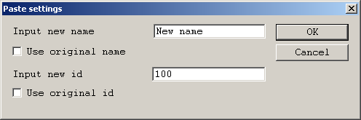

After inputting a new name,
- The child item names of the pasted item are not changed.
- The entire items IDs of the pasted item are changed.

Menus

File
              - File menu
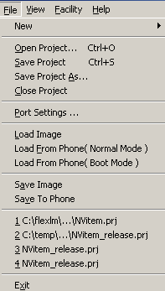

                - File menu items
Menu Item | Description
Open Project… | Open a project file.
Save Project… | Save a project file.
Save Project As… | Save the project file as another.
Load Image | Load the parameter values from the image file.
Load From Phone… | Load parameters from the hardware through the serial port.  - Load From Phone (Normal Mode): load parameters in normal mode  - Load from Phone (Boot Mode): load parameters in boot mode  Before performing this operation, ensure that the serial port is correctly configured.
Save Image | Save the parameter values in the image file. The image file is named NVItem.bin and saved in the same directory as the project file.
Save to Phone… | Write the parameters in the hardware module through the serial port. Before performing this operation, ensure that the serial port is correctly configured.  This function can be used only when the module is in boot mode.
Close Project | Close the project file. If the project file is modified, you are prompted to save it.
Exit | Exit the program.

New
              - New submenu items
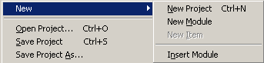

                - New submenu items
Submenu Item | Description
New Project | Create a new project file.
New Module | Create a new module file. The new module information must be input.
New Item | Create a new item in a module file.
Insert Module | Insert a module file into the current project file. The module file name cannot be the same as the project file name. Otherwise, it cannot be inserted. The inserted module file is in the same directory as the project file.

Choose New > New Module. The New Module dialog box is displayed, as shown in Figure 3-2.
              - New Module dialog box
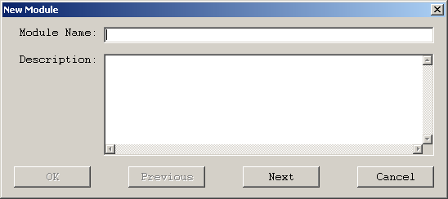

                - New Module dialog box elements
Elements | Description
Module Name text box | Module name
Description text box | Module description
OK button | Click this button to create the module file and close the dialog box.
Next button | Click this button to create the module file and the next file.
Previous button | Click this button to view the previous module file.

Port Settings…
              - Port Settings dialog box
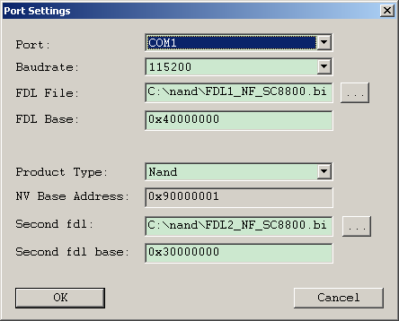

                - Port Setting dialog box elements
Elements | Description
Port drop-down list box | Serial port that connects the module
Baudrate drop-down list box | Baud rate of the serial port
FDL File text box | FDL file directory  The FDL file is used to write the parameters into the hardware module and is provided by Spreadtrum with the program.
FDL Base text box | FDL download address
Product Type drop-down list box | Product type  Different products have different NV addresses. If the product type is not included, select Customize and input the address in the NV Base Address text box.
Second fdl text box | If NAND Flash is used, this text box is available.

Note:
The NV Base Address only influences the Load from phone (Boot Mode) and Save to phone operations.

Load From Phone( Boot Mode )
This feature is used to read fixnv in download mode，Operation steps are as follows：
            - Loading the NV project
            - select download Port in “Port Settings” menu，At the same time the configuration of FDL1/FDL2 information
            - Manual trigger device to enter the download mode (such as: press the volume down + USB + power)
            - Select the menu to complete the function of reading fixnv.

Save To Phone( Boot Mode )
This feature is used to write fixnv in download mode，Operation steps are as follows：
            - Loading the NV project
            - Modify nvitem
            - select download Port in “Port Settings” menu，At the same time the configuration of FDL1/FDL2 information
            - Manual trigger device to enter the download mode (such as: press the volume down + USB + power)
            - Select the menu to complete the function of writing fixnv.

Load &From Phone( Normal Mode )
This function is used to read the runningNV information of the device in power on mode，Operation steps are as follows：
            - Loading the NV project
            - select diag Port in “Port Settings” menu
            - Select the menu to complete the function of reading fixnv.

Save Image....
              - Save Imag Diag Box
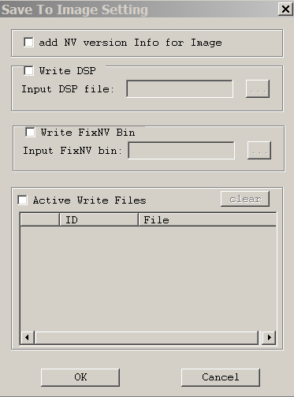
                - save Image dialog box elements
界面元素 | 说明
“VersionInfo”check box | Selected this check box,it will add nv version information into bin file.
“Write DSP”check box | Selected this check box,it will add the “DSP File” into bin file.
“DSP file”edit file box | DSP file path.
“Write FixNV Bin” check box | Selected this check box, it will add the “fixNV bin File” to current project bin file.
“FixNV bin” edit file box | FixNV bin File Path
“Active Write Files” check box | Selected this check box, then it can write other files into bin file.. And each file write forms like: ID +file Length + file content
“Clear” button | Clear Ctrl List。
First column of Ctrl List Table | Double clicked, the check box will be found, and selected this check box, then can add the current Line described file to bin.
“ID”column edit text box | Double clicked, input the File ID, required not repeated ID from this project。
“File”Column edit text box | Double clicked, input the file path.

Facility
              - Facility menu
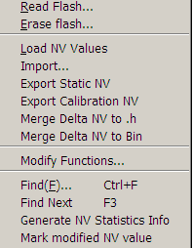

                - Facility menu items (part)
Menu Item | Description
Erase Flash | Erase Nor Flash.  When using this function, the Second Fdl text box in the Port Settings dialog box must be filled in.
Erase Nand Flash | Erase Nand Flash  When using this function, the Second Fdl text box in the Port Settings dialog box must be filled in.
Import… | Load (*.nv) files.
Export static NV | Export static nv parameters as an excel table. Which nvm file has description like “static”, it will see as a static nv parameter.
Export calibration NV | Export calibration nv parameters as an excel table. Which nvm file has calibration attribute, it will see as a calibration nv parameter.
Merge Delta NV to .h | Merge some NV files to a header file.
Merge Delta NV to .bin | Merge some NV files to bin file or merge the bin to moderm.bin
Mofiy Funcstions | Modify NV items value functions。
Find(F)… Ctrl+F | Find item by name
FindNext | Find next item.

Erase Flash
Select Erase Flash. The dialog box shown in Figure 3-1 is displayed.
              - Erase Flash dialog box
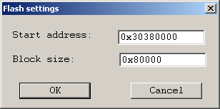

Here, if the port parameters are not set, the Port Settings dialog box is displayed.

Modify Functions
Select Modify Functions. The dialog box shown in Figure 3-13 is displayed：
              - Modify Functions dialog box
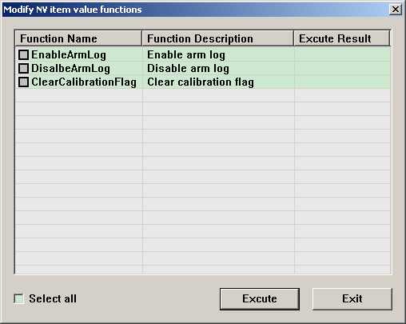
Select the functions and then click the button “Execute”, and the result list in “Execute Result”.

Find
Click Menu “Find”, it will show a dialog as:
              - Find Dialog
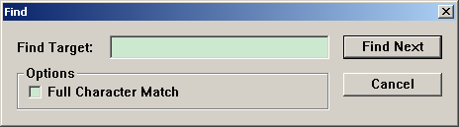
Set the name you want to find. If it find one match item, you can press “F3” key to find next.

Merge delta.nv to .h
Menu Facility > Merge delta.nv to .h, it will show a dialog，and then choose the path which including delta.nv files you want to merge a header file.

3.3.2.6 Merge delat.nv to Bin
Menu Facility > Merge Delta.nv to Bin, it will show a diaglog as below：
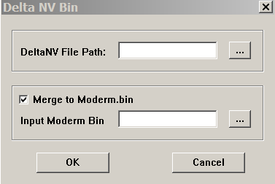
Set the fullpath which including delta.nv files. And If you selected “Merge to Moderm.bin”, you can set the CP Image Path, and then you will merge these delta.nv files to CP Image file.

Taskbar
              - Taskbar icons

                - Taskbar icons
Icon | Description
 | Open a project file
 | Save a project file
 | Write the parameter values into the mobile
 | At sunken state, the data in the column of item content is showed as hex string, otherwise is showed as decimal string.
 | Version information

Command line
NVEditor supports command line.
Parameters as below：
NVEditor.exe. <xxx.prj> [ [ [ [ [yyy.nv ] dsp.bin ] zzz.txt ] –L] –W ][-T][-m MergeFilePath [headerFileName]] | -c MergeFilePath [BinFileName]]

xxx.prj [input] it is project file(*.prj). it is must, and others is optional.
yyy.nv [input] it is (*.nv) file, and used to modify the NV item value.
Dsp.bin [input] it is dsp bin file, and NVEditor will add it to NV bin file.
zzz.txt [output] it is the log file.
-L if use this flag, the NV bin generate is little endian, otherwise is big endian
–W if use this flag, the console window of NVEditor will wait and you can see the log information, otherwise the window will close immediately.
-v if use this flag, the nvitem.bin will include the version information of the NV, id = 0, and length = 36;
-id if use this flag, it will requried two other parameters: FileID FilePath. And NVEditor will add this file to NV bin file.
FileID [input] File Item ID.
FilePath [input] File Path., NVEditor will add it to NV bin file.
-m | -c these two flags uesd to deal with Delta NV files according to different projects’ requirement.
-m if use this flag, it must be require one parameter – MergeFilePath, which describe the NV files’ path, and another parmeter is an optional parameter, which will determine the final headerfile naem, its default value is nv_config.h in MergeFilePath directory.
-c if use this flag, it it must be require one parameter – MergeFilePath, which describe the NV files’ path, and another parmeter is an optional parameter, which will determine the final bin file, its default value is delta_nv.bin in MergeFilePath directory, or parse .nv files to moderm.bin in marked location.
-f if use this flag, it must be requre one parameter—FixNVBin FilePath, which describe the File Path of “fixNV.bin”, which will merge to current nvproject bin file
-h if use this flag, it must be require ome parameter—HashHeader, which records the hash value generated by the whole nv project.
-T [input]if use this flag, the NV bin without the “FF” end-Flag; otherwise, without this flag, the NV bin will include the End-Flag “FF”.
e.g.: NVEditor.exe D:\nvitem.prj D:\IMEI.nv D:\error.txt -L -W
NVEditor.exe D:\nvitem.prj –id 111 D:\IMEI.xml –id 112 D:\IMEI.bin

Files

Project File
A project file (*.prj) saves the names and the number of the module files.

Module File
To facilitate management, the NV parameters are categorized. Each category is saved in a file, namely, the module file (*.nvm), in the same directory as the project file.

Image File
The image file is a binary file automatically generated from the NV parameter values. It saves the content to be written into the Flash.
Each time you modify the parameters, choose File > Save Image. The image file is generated. Alternatively, choose File > Save To Phone.

Values that Can Be Modified
The values in the following modules can be modified:
- mic_gain and aux_mic_gain in calibrationpara
- nv_type
- nv_classmark
- User created modules
nv_type and user created modules support new item insertion.

Points for Attention
Do not modify these files. Otherwise, hardware damages may be caused.

